ServletRequest Interface

An object of ServletRequest is used to provide the client request information to a servlet such as content type, content length, parameter names and values, header informations, attributes etc.

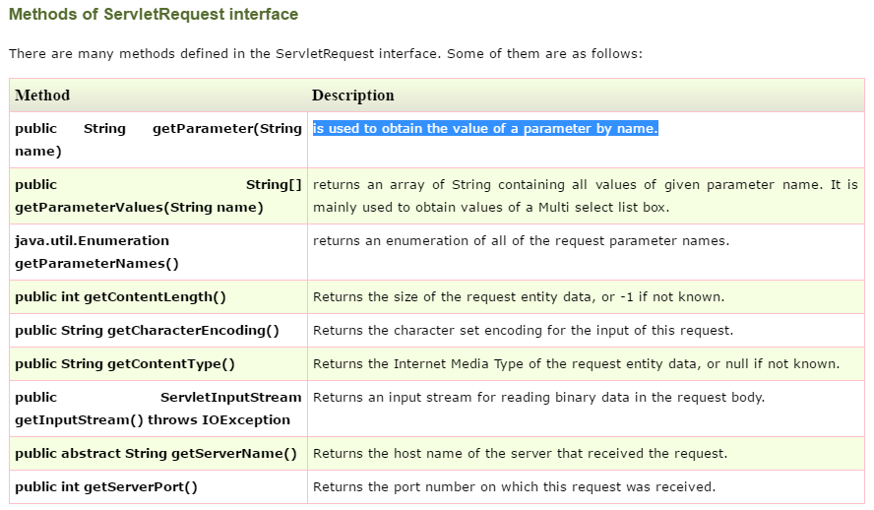

Now making form to understand this better->

1.make make all the servlet steps then ad this code into servlet and also make index.html

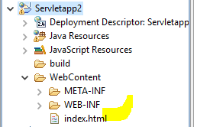

Make index.html as follows

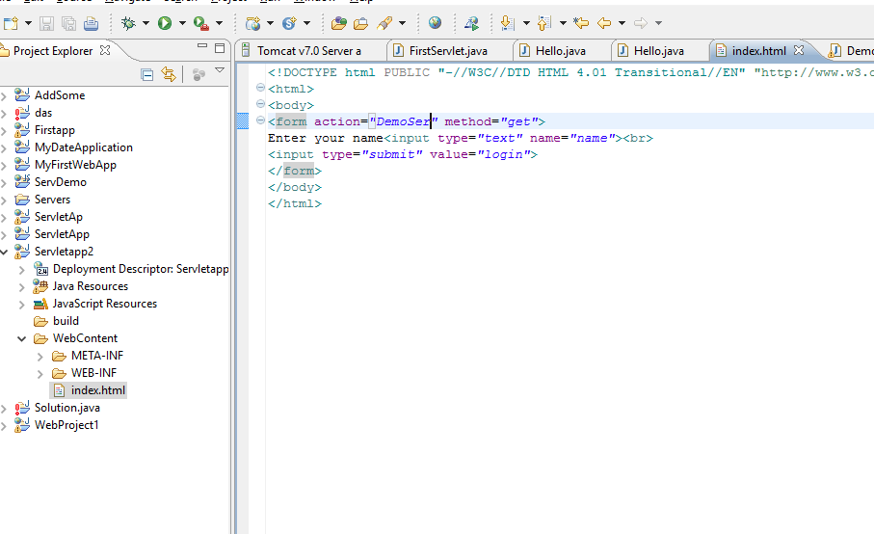

And make the servlet named DemoSer because in action we have gived the name DemoSer;

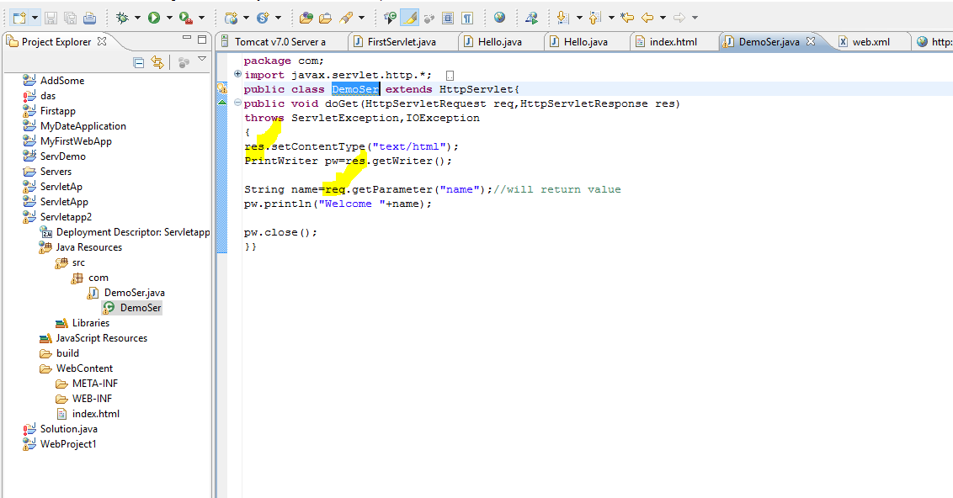

After run as on server

